3Q PROJECT
PROJECT TITLE: NETWORK WITH ISP ROUTERS
PROJECT ENGINEER (NAME/3Q REG.NO): Abhishek V - 3QI2611

Project Plan Sheet
1. Network Establishment
- Design and implement a high-performance integrated architecture featuring a 4-Router Core Transit Cloud.
- Interconnect 6 Edge Branches to the core cloud to establish a tiered enterprise backbone.
- Ensure all connections follow the hierarchical model: Core (Transit), Edge (Distribution), and Access (Local LAN).
2. IP Addressing Scheme
- WAN Connections: Use 30-bit subnet masks (255.255.255.252) for all point-to-point Serial links within the Core Cloud and Edge-to-Core links.
- LAN Connections: Use 24-bit subnet masks (255.255.255.0) for the branches.
3. IP Management & Relay Configuration
- Localized Services: Configure a DHCP service in the Edge Router in each branch LAN.
- Address Acquisition: Ensure all PCs receive Dynamic IPs from the DHCP service via the Edge Router gateway.
4. Routing Configuration
- Protocol: Implement EIGRP across all 10 routers.
- Convergence: Configure EIGRP to ensure sub-second convergence and dynamic path selection across the Core Transit Cloud.
- Optimization: Use wildcard masks and no auto-summary to ensure precise route advertisements for /30 and /24 subnets.
6. IP Assignment Strategy
- Static IPs: Assign static addresses to all infrastructure components:
  - Core & Edge Routers.
- Dynamic IPs: Ensure all end-user PCs receive IPs dynamically from the Edge Router.

Implementation Timeline:
- Phase 1: Project Initiation & Proposal
- Phase 2: Project Planning
- Phase 3: Project Execution / Implementation
- Phase 4: Monitoring and Controlling
- Phase 5: Project Closing
Challenges and Opportunities:
During the configuration of the network, the main issue and problem faced was assigning the dynamic IP while the distributed service model was new to us. Routing was known, but integrating EIGRP across a 10-router cloud was very challenging. Rather than challenges, I was introduced to many new things where I got to know about how we can use 30- and 24-bit subnet masks in WAN and LAN respectively.

Detailed reason in case the project was not completed on time:
The submission was delayed by 2 weeks due to the challenges in configuration of DHCP service, where IP addresses were not assigned properly for the devices across the edge branches. Though we finished it somehow, troubleshooting the IP allocation took much of our time though we knew the concept. Another problem was EIGRP routing, which was not configured correctly at first, causing issues with neighbour adjacencies across the 4-router core cloud. However, all problems have been successfully resolved and the network is fully operational.

PHASE: PROJECT INITIATION & PROPOSAL
1. Project Overview
The objective of this phase is to evolve the network into a high-performance 10-router integrated architecture. This project establishes a 4-router "Core Transit Cloud" to interconnect 6 "Edge" branches. A key design feature is the transition to a tiered routing model, where the backbone handles high-speed data transit between branches, while the Edge routers focus on managing local network segmentation and service relaying.
2. Determining Project Necessities
To successfully integrate the cloud backbone and distributed network services, the following technical and infrastructure requirements have been established:

Infrastructure Requirements
- 4 Core Routers: Dedicated to high-speed transit (Backbone).
- 6 Edge Routers: Responsible for Inter-VLAN routing (Router-on-a-Stick) and IP Relay services.
- Branch Switch Fabric: Two switches per Edge router to support local connectivity.
- Localized Service Nodes: Dedicated hardware connected directly to the switch fabric in each LAN to handle local network requests.
Protocol Requirements
- Routing Protocol: EIGRP (Enhanced Interior Gateway Routing Protocol) enabled on all 10 nodes for high-speed, dynamic path discovery across the enterprise.
3. Project Proposal & Design Logic
Objective: To design a network that separates internal branch traffic from backbone transit, ensuring that local services remain functional within each branch independently.
Proposed Solution
- The Transit Cloud: A 4-router core will be established using Serial links. This "Cloud" acts as a high-speed highway for data moving between the 6 edge locations, ensuring that branch-to-branch communication is efficient and redundant.
- Service Relaying: Edge routers will be configured with DHCP. The routers will act as "DHCP Server," catching local broadcast requests.
4. Implementation Steps (Draft)
- Backbone Physical Setup: Connect the 4 Core Routers using Serial cables in a meshed topology to form the transit cloud.
- Edge Linkage: Establish physical connections between each of the 6 Edge Routers and the Core Cloud routers.
- Local Switch & Service Configuration: Connect local service hardware to the designated ports on the edge switch fabric.
- Dynamic Routing Activation: Enable EIGRP on all 10 routers and advertise local subnets and serial backbone links.
PHASE: PROJECT PLANNING
1. Defining Tasks
To manage the integration of the core cloud and the localized relay services, the project is broken down into structured technical tasks:
- Task 1: Topology Mapping & Physical Cabling
  - Designing the 4-router mesh (Core Cloud) and the 6-branch (Edge) connections.
  - Establishing Serial links for the backbone and Ethernet/Fiber for the local LANs.
- Task 2: DHCP Configuration
  - Configuring all routers to be the DHCP server for its local network.

- Task 3: Dynamic Enterprise Routing
  - Configuring EIGRP across all 10 routers using a unified Autonomous System (AS).
  - Verifying route propagation and neighbour adjacencies from the local LANs through the Core Cloud.
2. Project Deliverables
The following deliverables will be produced to confirm the successful completion of the planning and implementation stages:
- Hierarchical Topology Diagram: A blueprint showing the Core Cloud, Edge Routers, and localized LAN segments.
- IP Addressing & Subnet Log: A detailed plan for the WAN backbone and the VLAN-specific subnets.
- Functional Relay System: Evidence of successful traffic relaying between the Edge gateway and localized LAN services.
- EIGRP Convergence Report: Verification that all 10 routers have successfully exchanged routing tables and established neighbour relationships.

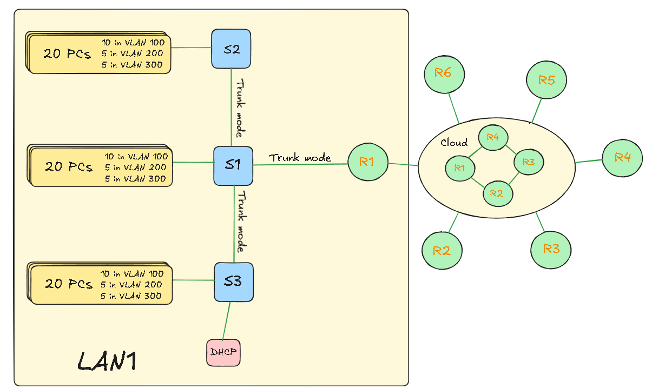

PHASE: PROJECT EXECUTION / IMPLEMENTATION
1. Backbone Deployment (Core Cloud)
The first stage of execution involved the physical and logical establishment of the 4-router core cloud. These routers were interconnected using Serial DCE/DTE cables to form a high-speed transit backbone using a meshed topology.

One Example Core Serial Interface Configuration:
Core_Router# configure terminal
Core_Router(config)# interface Serial0/0/0
Core_Router(config-if)# ip address 192.168.7.24 255.255.255.252
Core_Router(config-if)# no shutdown
2. Edge Connectivity & Local Services
The 6 Edge Routers were linked to the core cloud. Simultaneously, localized service nodes were connected to the edge switch fabric within each LAN to ensure distributed resource availability.
Switch Port Configuration: Dedicated ports on the edge switches were configured for service nodes.
3. Dynamic Routing Convergence (EIGRP)
To achieve full reachability and fast convergence, EIGRP was enabled on all 10 routers. This allows the 4-router cloud to learn and calculate optimal paths for all 18 VLANs distributed across the edge.
One Example Global EIGRP Configuration:
Router(config)# router eigrp 100
Router(config-router)# network 192.168.1.0 0.0.0.7 # Backbone Cloud
Router(config-router)# network 192.168.2.0 0.0.0.255 # Local LAN segments
Router(config-router)# no auto-summary
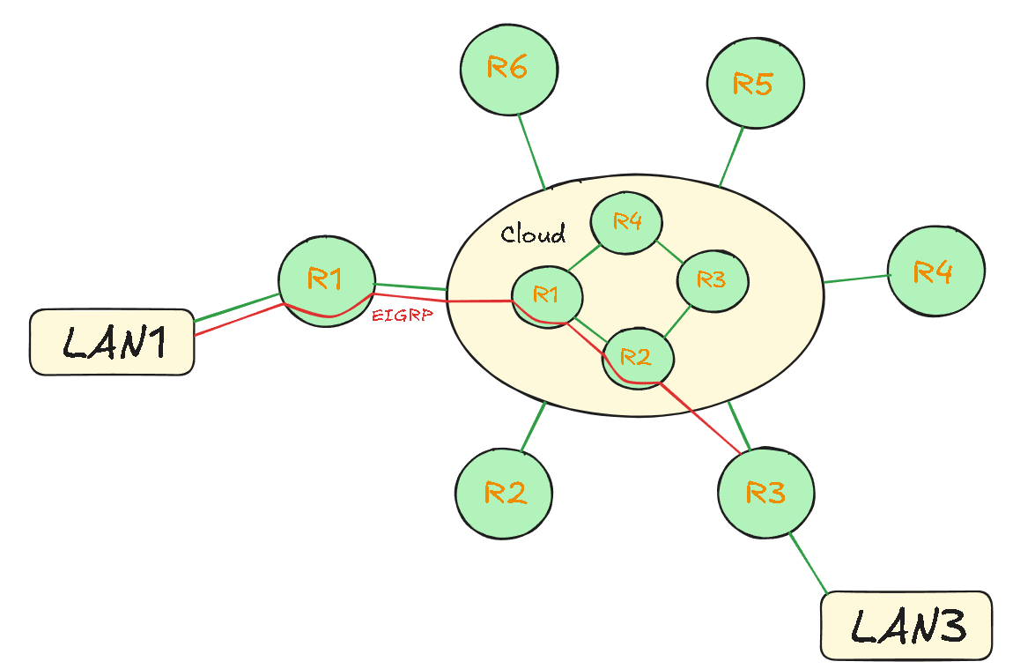

PHASE: MONITORING AND CONTROLLING
1. Tracking Progress & Performance
Monitoring the integrated 10-router infrastructure ensures that the high-speed transit cloud correctly carries traffic between the distributed LAN segments using the EIGRP protocol.
- Backbone Convergence Monitoring: Utilizing routing protocol verification to ensure the 4-router core cloud has established neighbour adjacencies and is successfully sharing routes with all 6 edge routers.
Verification Commands
# Verify the routing table for EIGRP convergence (Look for 'D' routes)
Router# show ip route eigrp

# Verify EIGRP neighbor relationships and uptime
Router# show ip eigrp neighbours
2. Change & Risk Management
- Risk: Improper K-Value calculation or AS mismatch in EIGRP.
  - Mitigation: Standardized Autonomous System 100 across all 10 routers and maintained default K-values to ensure stable neighbour adjacencies.
- Risk: Service node failure at the switch level.
  - Mitigation: Because services are localized per branch, a failure in one LAN does not affect the connectivity or services of the other five branches.
- Change: Transitioned from RIP to EIGRP to support sub-second convergence and advanced metric calculation, including specifically advertising the backbone serial links (10.0.0.0) and local subnets (192.168.2.0) with wildcard masks.

PHASE: PROJECT CLOSING
1. Finalizing Deliverables
The final stage of the project marks the successful integration of the 4-router core cloud and the localized relay infrastructure. All physical and logical artifacts are consolidated for handover.
- Final Hierarchical Topology: A comprehensive map illustrating the 4-router transit core and the 6-router edge gateways.
- Configuration Repository: A finalized archive of the CLI scripts for the backbone routers (EIGRP AS 100 settings) and the edge routers.
- IP Addressing Schema: A documented log of the WAN /30 subnets used for the core cloud and the localized /26 subnets used for the various VLAN departments.

2. Reviewing Performance
The network was evaluated against the technical objectives established during the Initiation Phase to ensure full compliance.
- Backbone Efficiency: EIGRP successfully achieved full convergence across all 10 nodes. Traceroute tests confirm that inter-branch traffic successfully transits the 4-router core cloud using optimized paths based on bandwidth and delay.
- Resiliency Test: Simulated failure of a single core router link confirmed that EIGRP (via the DUAL algorithm) instantly transitioned to feasible successors, maintaining connectivity between all 6 branches without significant downtime.
Final Verification Summary:
# Final audit of the enterprise routing table for EIGRP
Router# show ip route eigrp
3. Network Design
